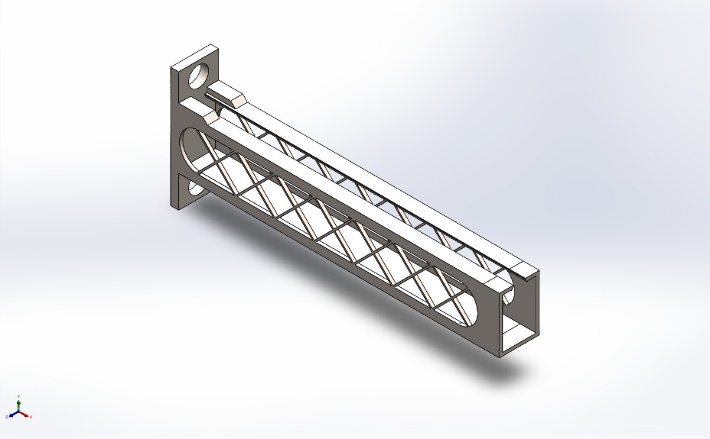
  Simulation of Cantilever Bracket
  Date: 07 June 2026
  Designer: Solidworks
  Study name: Modal Time History
  Analysis type: Linear dynamic analysis (Modal Time History)
  Table of Contents
  Description 1
  Assumptions 2
  Model Information 2
  Study Properties 3
  Units 3
  Material Properties 4
  Loads and Fixtures 4
  Connector Definitions 5
  Interaction Information 5
  Mesh information 6
  Sensor Details 8
  Study Results 10
  Conclusion 12

Description
No Data

Assumptions

Model Information

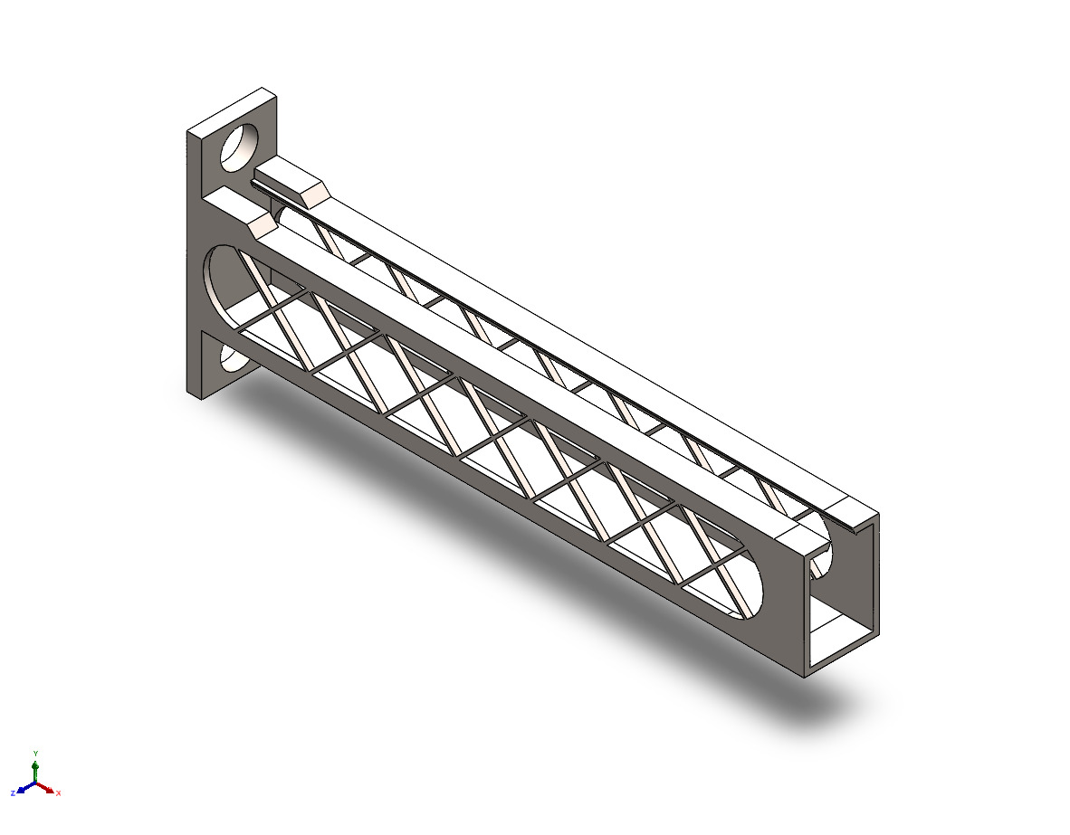
Model name: Cantilever Bracket
Current Configuration: Child Reborn
Solid Bodies
Document Name and Reference | Treated As | Volumetric Properties | Document Path/Date Modified
Mirror7  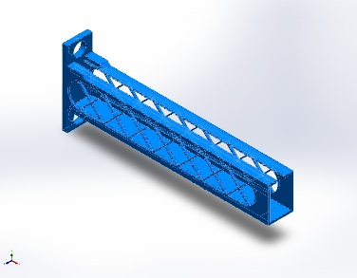 | Solid Body | Mass:269.821 kg  Volume:0.0350416 m^3  Density:7,700 kg/m^3  Weight:2,644.24 N | C:\Users\asus\Documents\Solidworks assignments\Chair\Cantilever Bracket.SLDPRT  Jun 7 12:05:11 2026

Study Properties
Study name | Modal Time History
Analysis type | Linear dynamic analysis (Modal Time History)
Mesh type | Solid Mesh
Number of frequencies | 15
Decouple the mixed free body modes | Off
Solver type | FFEPlus
Soft Spring: | Off
Incompatible bonding options | Automatic
Thermal option | Include temperature loads
Zero strain temperature | 298 Kelvin
Include fluid pressure effects from SOLIDWORKS Flow Simulation | Off
Start time | 0 Seconds
End time | 1 Seconds
Time increment | 0.01 Seconds
Dead Load Effects | Off
Result folder | SOLIDWORKS document (C:\Users\asus\Documents\Solidworks assignments\Chair)

Units
Unit system: | SI (MKS)
Length/Displacement | mm
Temperature | Kelvin
Angular velocity | Rad/sec
Pressure/Stress | N/m^2

Material Properties
Model Reference | Properties | Components
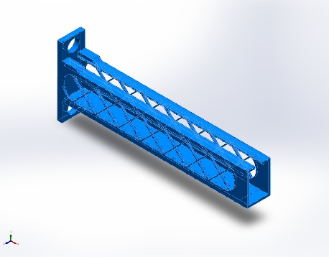 |  | SolidBody 1(Mirror7)(Cantilever Bracket)
  Name: | Alloy Steel
  Model type: | Linear Elastic Isotropic
  Default failure criterion: | Max von Mises Stress
  Yield strength: | 6.20422e+08 N/m^2
  Tensile strength: | 7.23826e+08 N/m^2
  Elastic modulus: | 2.1e+11 N/m^2
  Poisson's ratio: | 0.28
  Mass density: | 7,700 kg/m^3
  Shear modulus: | 7.9e+10 N/m^2
  Thermal expansion coefficient: | 1.3e-05 /Kelvin
Curve Data:N/A

Loads and Fixtures
Fixture name | Fixture Image | Fixture Details
Fixed-1 | 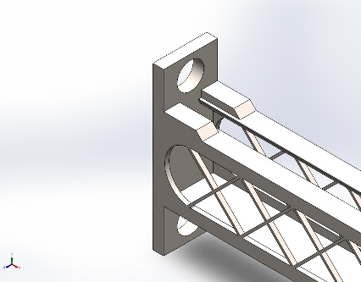
  Entities: | 1 face(s)
  Type: | Fixed Geometry
Resultant Forces
Components | X | Y | Z | Resultant
Reaction force(N) | -265,984 | -26,435.2 | -1,321.45 | 267,298
Reaction Moment(N.m) | 0 | 0 | 0 | 0

Load name | Load Image | Load Details | Function Curve
Base Excitation-1 | 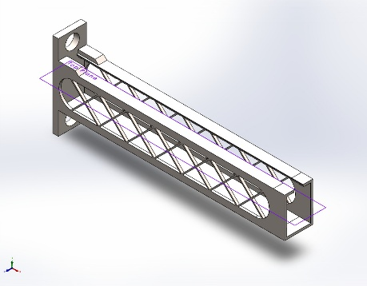
  Reference: | Top Plane
  Type: | Acceleration
  Translation: | ---, 0.5, -10
  Units: | in
  Phase Angle: | 0
  Units: | deg
  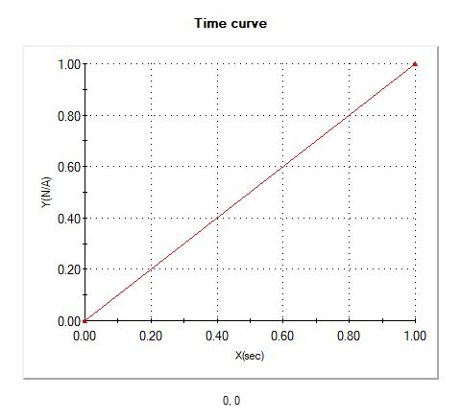
  Time curve

Connector Definitions
No Data

Interaction Information

Interaction | Interaction Image | Interaction Properties
Global Interaction | 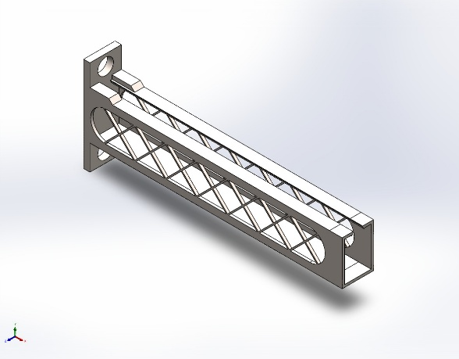
  Type: | Bonded
  Components: | 1 component(s)
  Options: | Independent mesh

Mesh information
Mesh type | Solid Mesh
Mesher Used: | Blended curvature-based mesh
Jacobian points for High quality mesh | 16 Points
Maximum element size | 275.576 mm
Minimum element size | 102.239 mm
Mesh Quality | High

Mesh information - Details
Total Nodes | 458961
Total Elements | 241739
Maximum Aspect Ratio | 9.2901
% of elements with Aspect Ratio < 3 | 95.2
Percentage of elements with Aspect Ratio > 10 | 0
Percentage of distorted elements | 0
Time to complete mesh(hh;mm;ss): | 00:00:37
Computer name:

Mesh Control Information:
Mesh Control Name | Mesh Control Image | Mesh Control Details
Control-1 | 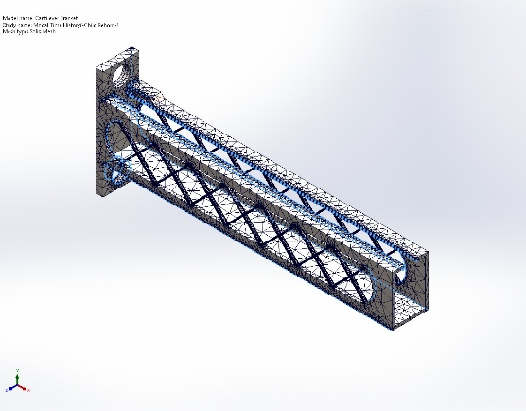
  Entities: | 25 edge(s)
  Units: | mm
  Size: | 4.8532
  Ratio: | 4.8532
Control-2 | 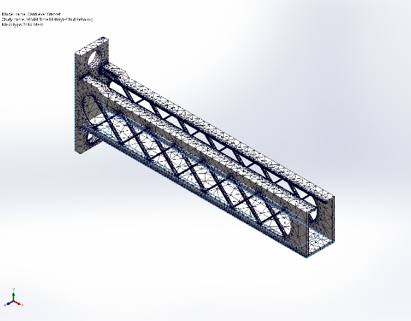
  Entities: | 23 edge(s)
  Units: | mm
  Size: | 28.5
  Ratio: | 28.5
Control-4 | 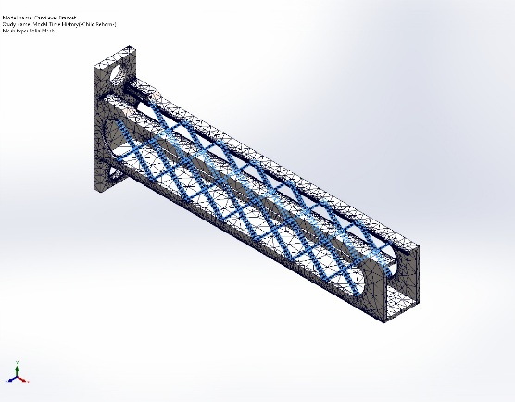
  Entities: | 224 edge(s), 1 face(s)
  Units: | mm
  Size: | 2.6846
  Ratio: | 2.6846

Mesh Quality Plots
Name | Type | Min | Max
Quality1 | Mesh | - | -
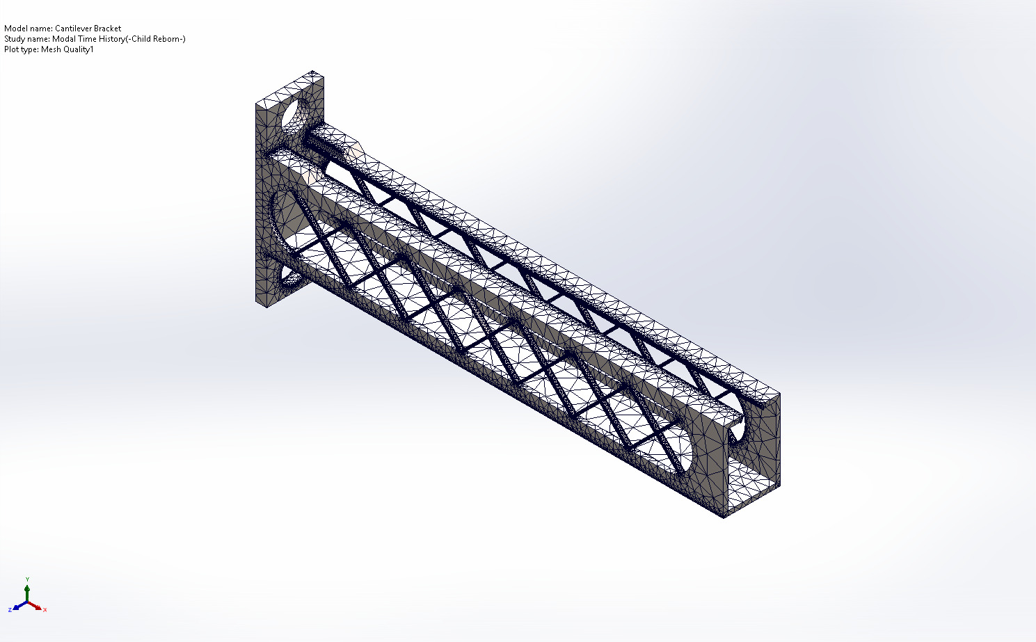
Cantilever Bracket-Modal Time History-Quality-Quality1

Sensor Details

Sensor name | Location | Sensor Details
Mass1 | 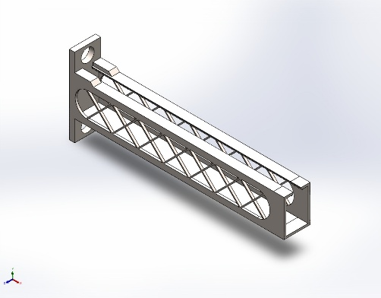 | Value : 41,695.41 g  Entities :  Result :Stress  Component :VON: von Mises Stress  Criterion :Model Max  Step Criterion : Across all Steps  Step No.:1  Alert Value: NA
Stress1 |  | Value : 53221724.000 N/m^2 @ 1 sec  Entities :  Result :Stress  Component :VON: von Mises Stress  Criterion :Model Max  Step Criterion : Across all Steps  Step No.:1  Alert Value: NA
Displacement1 |  | Value : 0.788 mm @ 1 sec  Entities :  Result :Displacement  Component :URES: Resultant Displacement  Criterion :Model Max  Step Criterion : Across all Steps  Step No.:1  Alert Value: NA
Mass2 |  | Value : 41,695.41 g  Entities :  Result :Stress  Component :VON: von Mises Stress  Criterion :Model Max  Step Criterion : Across all Steps  Step No.:1  Alert Value: NA
Stress2 |  | Value : 53221724.000 N/m^2 @ 1 sec  Entities :  Result :Stress  Component :VON: von Mises Stress  Criterion :Model Max  Step Criterion : Across all Steps  Step No.:1  Alert Value: NA
Displacement2 |  | Value : 0.788 mm @ 1 sec  Entities :  Result :Displacement  Component :URES: Resultant Displacement  Criterion :Model Max  Step Criterion : Across all Steps  Step No.:1  Alert Value: NA
Mass3 |  | Value : 41,695.41 g  Entities :  Result :Stress  Component :VON: von Mises Stress  Criterion :Model Max  Step Criterion : Across all Steps  Step No.:1  Alert Value: NA
Stress3 |  | Value : 53221724.000 N/m^2 @ 1 sec  Entities :  Result :Stress  Component :VON: von Mises Stress  Criterion :Model Max  Step Criterion : Across all Steps  Step No.:1  Alert Value: NA
Displacement3 |  | Value : 0.788 mm @ 1 sec  Entities :  Result :Displacement  Component :URES: Resultant Displacement  Criterion :Model Max  Step Criterion : Across all Steps  Step No.:1  Alert Value: NA

Study Results

Name | Type | Min | Max
Stress1 | VON: von Mises Stress at Step No: 100(1 Seconds) | 1.708e+02N/m^2  Node: 421707 | 5.322e+07N/m^2  Node: 329
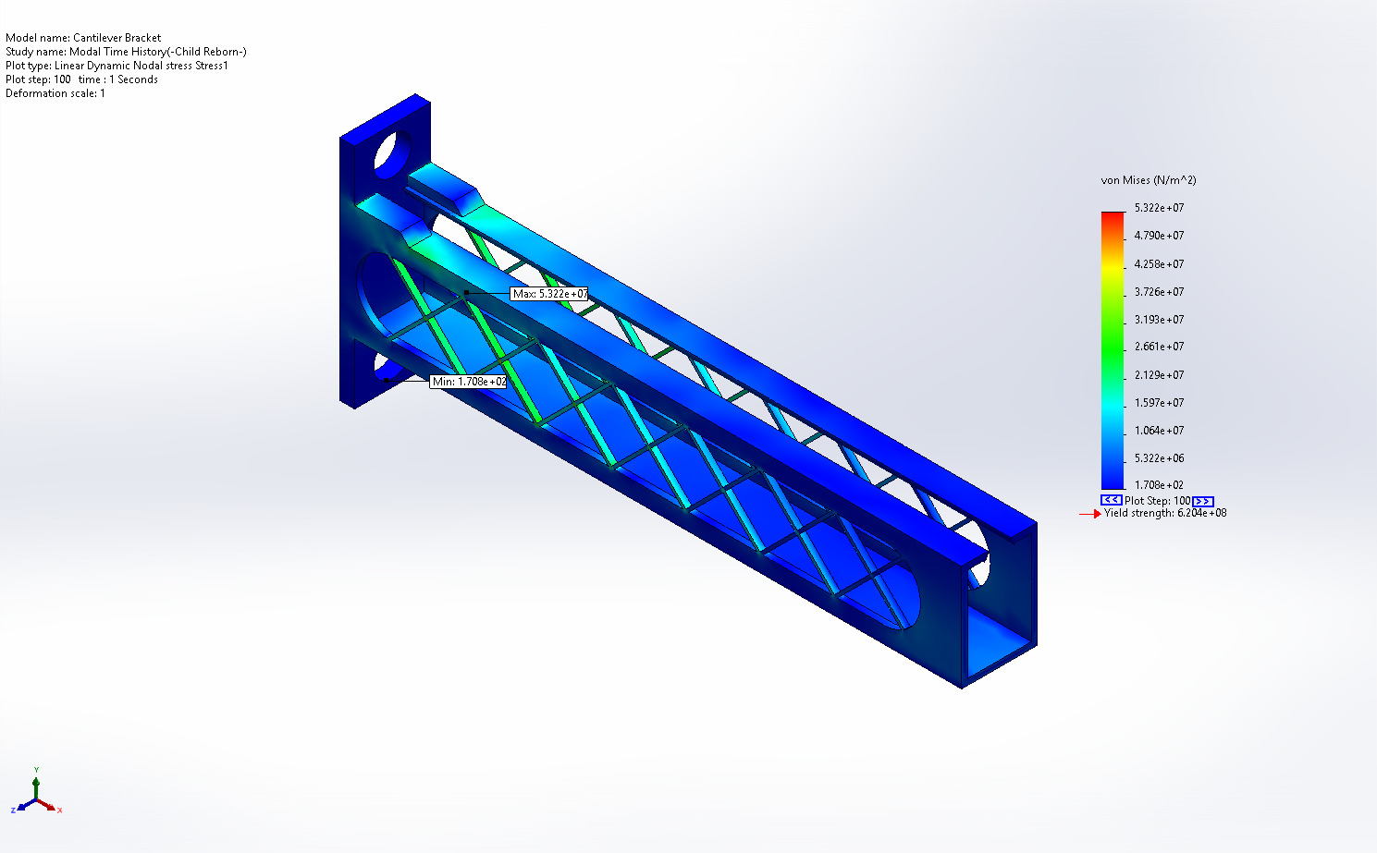
Cantilever Bracket-Modal Time History-Stress-Stress1

Name | Type | Min | Max
Displacement1 | URES: Resultant Displacement at Step No: 100(1 Seconds) | 0.000e+00mm  Node: 30 | 7.883e-01mm  Node: 368
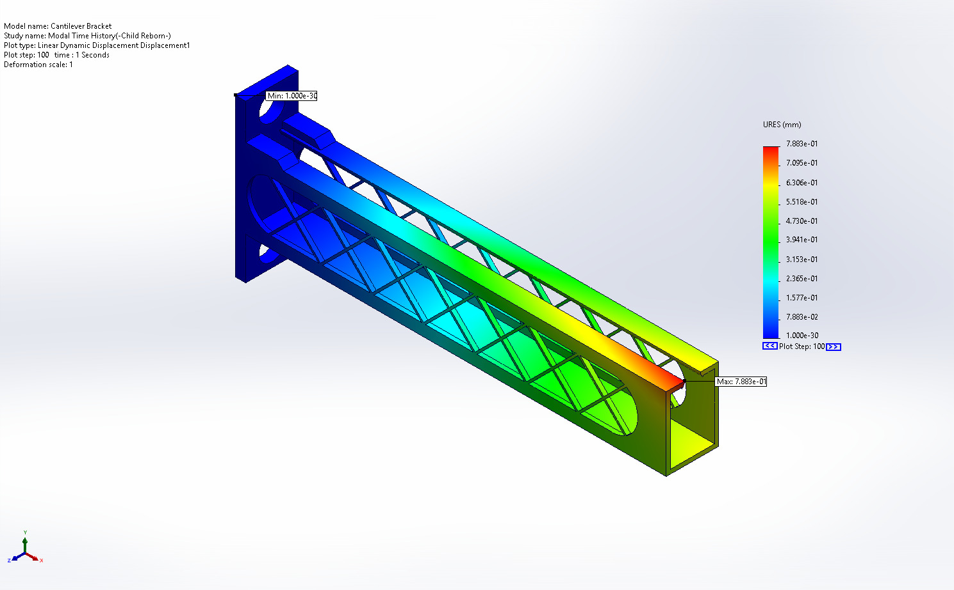
Cantilever Bracket-Modal Time History-Displacement-Displacement1

Mass Participation (Normalized)
Mode Number | Frequency(Hertz) | X direction | Y direction | Z direction
1 | 32.045 | 1.1266e-11 | 7.0221e-12 | 0.4135
2 | 59.693 | 1.6294e-08 | 0.083356 | 1.4226e-08
3 | 82.685 | 2.1376e-05 | 0.41931 | 4.1717e-09
4 | 99.296 | 4.3707e-11 | 3.7333e-09 | 0.012923
5 | 135.84 | 3.8057e-10 | 7.6758e-09 | 0.086916
6 | 136.52 | 3.9917e-05 | 0.006041 | 2.5099e-07
7 | 159.98 | 1.7203e-10 | 1.2356e-08 | 0.035663
8 | 260.33 | 1.5038e-09 | 1.1549e-08 | 0.023582
9 | 280.26 | 0.00031227 | 0.11785 | 2.2854e-11
10 | 311.49 | 0.00014444 | 0.0002222 | 5.5157e-08
11 | 325.01 | 1.1756e-10 | 9.3699e-10 | 0.029141
12 | 372.44 | 0.00072315 | 0.010833 | 3.6406e-08
13 | 386.35 | 1.7013e-12 | 1.2751e-08 | 0.022782
14 | 463.44 | 4.0195e-10 | 1.6096e-08 | 0.001184
15 | 489.46 | 2.2449e-07 | 0.0017902 | 2.7313e-08
 |  | Sum X = 0.0012414 | Sum Y = 0.6394 | Sum Z = 0.62569

Conclusion

